DMRE 317
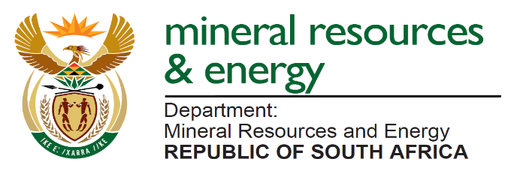
MINE ENGINEER’S CERTIFICATE OF COMPETENCY
DMR MENTOR REGISTRATION APPLICATION

INSTRUCTIONS:

1. Telephonic enquiries can be directed to the Secretary at 012 444 3935.

2. The following originally certified copies from South African Police Service (SAPS) not older than three (3) months must be attached to this application arranged in the following order:

- Identity Document
- Government Certificate of Competency
- Short CV detailing involvement in the mining industry with respect to area of mentoring
- Record of service on mine’s letterhead with contact details indicating more than three (3) years’ experience in the industry as a certificated Engineer
- Proof of being a holder of legal appointment in terms of Mine Health and Safety Act
- Certificate of competence as a mentor from an accredited institution
- Proof of number of Engineers-In-Training currently mentored <=five (5)

NB: Incomplete documents will not be considered

The Secretary
Mentor No: ……………………
For Office Use Only
Engineering Commission of Examiners
Private Bag X59

ARCADIA
0007

I, the undersigned, _______________________________________________________________
(PRINT NAME IN FULL)

______________________________ ____________________ _________________
(ID NUMBER) (RACE) (GENDER)

_____________________ __________________________________________________
(TEL/ MOBILE NUMBER) (E-MAIL ADDRESS)

______________________________________________________________________________
(POSTAL ADDRESS)

employed at

______________________________________________________________________________
(CURRENT EMPLOYER)

hereby apply to be registered as a mentor to Engineers-In-Training for the Electrical/Mechanical Engineering Certificate of Competency.

SIGNATURE: _____________________________ DATE: __________________

